Module-3

## Why is XPS a more qualitative than quantitative technique?

XPS is a more qualitative technique because the spectral interfaces are minimal Since XPS peaks for the core electrons tend to be fairly widely separated. XPS elemental analysis is based on core electron peaks usually straightforward.

## Give the number of electrons and best suitable pressure required for XPS measurement.

In XPS analysis the electrons emitted from atoms near the sample surface is 10-100 Angstroms and suitable pressure requires for high vacuum chamber is 10 -6 pa,for ultra

high Vacuum chamber is P ⦟ 10-7 pa

## What is the principle of XPS?

The working principle of XPS is the ejection of electrons from the surface of a sample in ultra high vacuum (UHV) condition. When an X ray (with energy hv) ejects out an electron ( by energy B.E). The ejected electron is called a photoelectron and this effect is

called photoelectric effect. The element present in the sample can be identified on the basis of kinetic energy (K.E) and the binding energy ( B.E) of their photo electron. The intensities of photoelectrons provide information about concentration of elements in a sample.

## Give only a schematic diagram for XPS instrumentation.



1. **What are the merits and demerits of XPS analysis? Merits**
2. XPS analysis is effective across a range of organic and inorganic materials.
3. XPS is a leading technique for analyzing [stainless steel passivation.](https://www.innovatechlabs.com/app-analysis-stainless-steel/)
4. XPS is also effective at identifying surface contaminants.

## Demerits

1. Size matters.
2. Challenges with reproducibility.
3. Samples must be compatible with a high vacuum environment.

## Define the terms: Binding energy and Work function in XPS analysis.

**Electron Binding energy** is a generic term for the minimum energy needed to remove an . electron from a particular electron shell for an atom or ion,

***E*binding =*E*photon – ( *E*kinetic +** ∅)

where *E*binding is the binding energy (BE) of the electron measured relative to the chemical potential, *E*photon is the energy of the X-ray photons being used, *E*kinetic is the kinetic energy of the electron as measured by the instrument

∅ **is the Work function** for the specific surface of the material, which in real measurements includes a small correction by the instrument's work function because of the contact potential. The work function-like term can be thought of as an adjustable instrumental correction factor that accounts for the few eV of kinetic energy given up by the photoelectron as it gets emitted from the bulk and absorbed by the detector.

## What are the applications of XPS? [Any two]

1. It is used for the surface analysis of organic and inorganic materials
2. It is used to study the fiberglass surface
3. It is an unique approach in probing electronic structures.

## DefineMiller indices with examples.

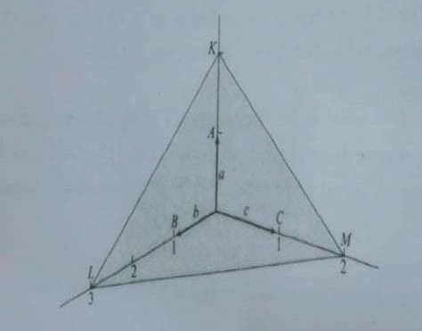

Miller introduced a set of integers (*hkl*) to specify a plane of the crystal. This set of three numbers (*hkl*) is known as ‘Miller indices’ of a particular plane of a crystal. “The Miller indices ((*hkl*) of a plane of a crystal are inversely proportional to the plane on the crystallographic axes”

1. It is customary to describe crystal planes by a set of Miller indices.
2. Find the intercept on the crystal axes as multiples of the lattice constants a1,b2,c3
3. Take reciprocals of these numbers and
4. Using an appropriate multiplier, convert the 1/intercept set to the smallest possible set of whole numbers
5. Represent the above as a set of integers (*hkl*) for a given plane of a crystal.

## For the intercepts x, y and z with values of 3,1and 2 respectively, find the Miller indices [Give the steps].

1. Intercepts : 3,1,2
2. Fractional intercepts: 1/3,1/1,1/2 ( reciprocal)
3. Miller indices: (263)

## Compute the MillerIndices for a plane intersecting at x=¼,y=1,andz=1/2.[Give the steps].

1. Intercepts : 1/4,1,1/2
2. Fractional intercepts: 4,1,2 ( reciprocal)
3. Miller indices: (412)

## Give the expression for Bragg’s law and explain the terms involved in it.

Bragg diffraction occurs when radiation, with a wavelength comparable to atomic spacings, is scattered in a specular fashion by the atoms of a crystalline system, and undergoes constructive interference. For a crystalline solid, the waves are scattered from lattice planes separated by the interplanar distance *d*.

When the scattered waves interfere constructively, they remain in phase since the difference between the pathlengths of the two waves is equal to an integer multiple of the wavelength. The path difference between two waves undergo interference is given by 2*d*sin *θ*, where *θ* is the glancing angle

**2*d*sin *θ* = n *λ***

where *n* is a positive integer and *λ* is the wavelength of the incident wave. A diffraction pattern is obtained by measuring the intensity of scattered waves as a function of scattering angle. Very strong intensities known as Bragg peaks are obtained in the diffraction pattern at the points where the scattering angles satisfy Bragg condition.

1. **What is interplanar spacing in lattices? Give the expression taking an example.** The interplanar spacing or interplanar distance is the perpendicular distance between two successive planes in a family (hkl).

Interplanar Crystal spacing of cubic crystal families is defined as

dhkl = 𝑎

√ℎ2+𝑘2+𝑙2

## Determine the Miller indices (hkl) of the shaded planes below.

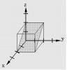 Intercepts: 2, ∞, 2

Fractional intercepts: 1/2, 1/∞, 1/2 Miller indices: (101)

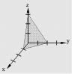 Intercepts: 1, 2, 3 :

Fractional intercepts: 1/1, 1/2, 1/3 Miller indices: (632)

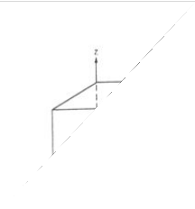 Intercepts: ∞, 1, ∞

Fractional intercepts: 1/∞, 1/1, 1/∞ Miller indices: (010)s

## Define Bragg’s law and give a diffraction pattern diagram.

The crystal diffract x- rays because the inter planar spacing in a crystal lattice is of the same order as that of the wavelength of the x-rays

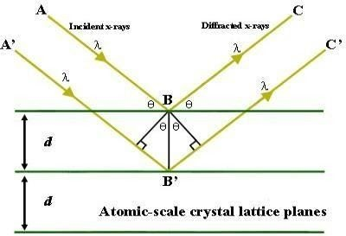

## Define the terms i.Criticaltemperature ii.Criticalvolume iii.Criticalpressure.

1. **Critical temperature (TC).** It is define as the temperature above which the gas cannot be liquefied
2. **Critical volume (Vc) .** The volume occupied by one mole of gas at critical temperature and pressure is called the critical volume (Vc).
3. **Critical pressure ( PC).** The minimum pressure required to liquefy the gas at the critical temperature is called Critical Pressure (Pc)

## Write a short note on ion-ion interactions.

Ion-ion interactions are an attractive force between ions with opposite charges. They are also referred to as ionic bonds and are the forces that hold together ionic compounds. Like charges repel each other and opposite charges attract. These Coulombic forces operate over relatively long distances in the gas phase.

## What is Dipole-dipole interaction ? Give an example.

**Dipole**-**Dipole interactions** result when two **dipolar** molecules **interact** with each other through space. When this occurs, the partially negative portion of one of the polar molecules is attracted to the partially positive portion of the second polar molecule.

Examples: NH3, SO2 HF, HCl

## What are London forces of interactions? Give examples.

The **London dispersion force** is a temporary attractive **force** that results when the electrons in two adjacent atoms occupy positions that make the atoms form temporary dipoles. The unequal distribution of electrons about the nucleus in an atom can induce some dipole in the atom. When another atom or molecule comes in contact with this induced dipole, it can be distorted that leads to an electrostatic attraction between either atoms or molecules.For example, consider London dispersion forces between two chlorine molecules. Here both

chlorine atoms are bonded through a covalent bond which forms by equal sharing of valence electrons between two chlorine atoms. The force of attraction between two [chlorine](https://byjus.com/chemistry/chlorine/) [molecules](https://byjus.com/chemistry/chlorine/) is the London dispersion force here which is due to unequal distribution of electron density in the molecule.

1. **Write a note on ion-dipole interactions.**

# An ion-dipole interaction is an attractive force that results from the electrostatic attraction between anions and a neutral molecule that has a dipole.Most commonly found in solutions. A positive ion (cation) attracts the partially negative end of a neutral polar molecule.A negative ion (anion) attracts the partially positive end of a neutral polar molecule.

1. **What is the modified form of VanderWaals equation?**

# Vander waals proposed his famous equation of state for a nonideal gas. He modified the ideal gas equation by suggesting that the gas molecules were not mass points but behave like rigid spheres having a certain diameter and that there exist intermolecular forces of attraction between them . The two correction terms introduced by Vander waals are

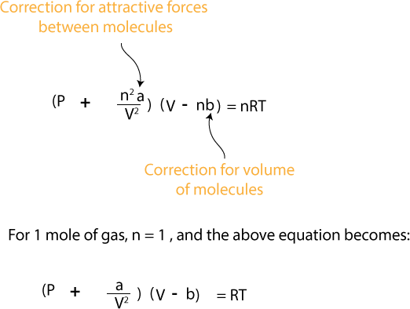

## Give the Clausius equation for real gases.

1. **What are the postulates of Fajan’s rule for ionic and covalent bonds? Give an example for the bonds mentioned.**

The molecules containing high positive charge on cation, high negative charge on anion, smaller cation or large anion are covalent in character. The molecules containing low positive charge on cation, low negative charge on anion, large cation or small anion are ionic in character.

In anhydrous chlorides like NaCl, MgCl2 and AlCl3, the polarizing power of the cations Na+, Mg2+, Al3+ increases in order Na+< Mg2+ < Al3+, since the positive charges on the cations also

increases in the same order. With the increase of polarization of Cl- anion by the cation (Na+, Mg2+, Al3+), the covalent character between the cation and anion of these chlorides also increases as we move from NaCl to AlCl3.

## First ionization energy of Al is lower than that of Mg. Comment on the statement.

Reason:-

Electronic configuration of Al = 1s22s22p63s23p1 Electronic configuration of Mg = 1s22s22p63s2

Al has one unpaired electron in its highest energy orbital (3p), and Mg's highest energy orbital (3s) has the paired electrons. It is easier to remove electrons from unpaired 3p1 than from paired 3s2.

It is energetically favorable for all the electrons in an orbital to be paired, which means that breaking up this pair would require more energy.

## How many numbers of geometries are possible in C.N4? Give an example.

Two different geometries are possible.

The **tetrahedron** is the most common. e.g tetrahedral Cobalt(II) complexes

while the **square planar** is found almost exclusively with metal ions having a d8 electronic configuration. e.g cis-PtCl2(NH3)2

## How many numbers of geometries are possible inC.N6? Give an example.

Three different geometries are possible.

**Hexagonal planar Geometry**: Unknown for first row transition metal ions, although the arrangement of six groups in a plane is found in some higher coordination number

geometries.

**Trigonal prism Geometry**: Most trigonal prismatic compounds have three bidentate ligands such as dithiolates or oxalates and few are known for first row transition metal ions.

**Octahedral (Oh):** The most common geometry found for first row transition metal ions, including all aqua ions.

## Define the terms i. Ionization energy, ii. Electron affinity and iii.

**Electronegativity**

* + 1. **Ionization energy**- The amount of **energy** required to remove an electron from an isolated atom or molecule.
    2. **Electron affinity-** The amount of energy released when an electron is added to a neutral atom to form an anion.
    3. **Electronegativity-** The tendency of an atom in a molecule to attract the shared pair of electrons towards itself.
  1. 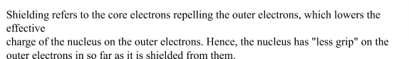 **What is effective nuclear charge and Shielding constant? Give their relationship.** The **effective nuclear charge** (often symbolized as Zeff or Z*) is the net positive **charge** experienced by an electron in a multi-electron atom. The term “**effective**” is used because the shielding effect of negatively charged electrons prevents higher orbital electrons from experiencing the full **nuclear charge**.

Zeff can be calculated by subtracting the magnitude of shielding from the total nuclear charge and the effective nuclear charge of an atom is given by the equation:

Zeff = Z-S

## Give the formula to calculate Shielding constant[σ]for an electron residing in n [sorp]subshell and also in“d”subshell.

The value of σ for an electron residing in (n – 1)d orbitals of (n – 1)th shell of an atom or an ion

1. There will be no contribution to the value of s by the electrons residing in ns orbitals in ns orbital.
2. Each of the remaining electrons present in (n – 1) d orbitals, makes a contribution of 0.35 Each of the electrons present in the (n – 1)s, (n – 1)p orbitals and inner shells [i.e. 1st 2nd, 3rd,….(n – 2)th shells] makes a contribution of 1.0

σ for a (n – 1)d electron = 0.35 × [No. of the electrons in (n – 1)d orbitals] + 1.0 × [No. of electrons in (n – 1)s, (n – 1)p orbitals and inner shells]

## List out elements from the following the most electropositive and electronegative element and give reasons. Li, Be, B, C, K and Fluorine.

Most electropositive element is K and most electronegative element is F

In the above list except K other elements belong to the same period (2 nd). On moving from left to right the electronegativity increases with increase in the number of outer electrons. Since F is the having more number of electrons in the outermost orbital, it is the most electronegative element. (present in the top right hand corner of the periodic table)

K is present in the first group. In groups from top to bottom the electronegativity decreases because of electron shielding effects. So compared with Li on the same group K is less electronegative. So the K is the most electro -positive element in the given list.

## Arrange Br, F, I and Cl in the order of increasing electron affinity and give reasons.

F > Cl > Br > I

On moving down the group the electron affinity decreases. Because of the steady increase in atomic radius of the elements

## Give the increasing order for Na, Al, Mg and Si atoms based on effective nuclear Charge and give reasons.

**Na <Mg <Al < Si**

All these elements belong to the 3rd period. We know that as we proceed from left to right in a period, the electrons are added to the orbital of the same main energy level. The addition of each electron increases the nuclear charge by one, so from Na to Si nuclear charge increases.

## Give the increasing order for Na, Al, Mg and Si atoms based on effective nuclear charge and give reasons.

The order of increasing effective nuclear charge is Na < Mg < Al < Si because, in a period, on moving from left to right, the electrons are added to the same principal shell. The added electrons shield each other poorly from the nucleus therefore the effective nuclear charge increases.

## What are atomic radii? Give its variation along the period and down the group taking examples.

The atomic radius is defined as one-half the distance between the nuclei of identical atoms that are bonded together.

In a period, from left to right, with increase in the atomic number, the atomic radius decreases due to increase in the nuclear charge which increases the attraction of the nucleus for the valence electrons.

For example, in the elements of the second period, the covalent radii decrease as we move from Li to F as shown below.

## Li (1.23) >Be(0.90) > B(0.82) > C(0.77) > N(0.75) > O(0.73) > F(0.72)

In a group, on moving from top to bottom, the atomic radius increases as a new energy level is added at each succeeding element but the number of valence electrons remains the same.

## Be (0.90) <Mg (1.36) <Ca (1.74) <Sr (1.91) <Ba (1.98)

1. **Arrange the following in the increasing order of atomic radii and give reasons: N, S, P and O.**

The correct order of atomic radii of N, S, P, and O follows the order O < N < S < P. On going from N to O, the nuclear charge increases. But the additional electron is added in the same energy level. Hence, due to shielding effect, the effective nuclear charge increases. The attraction of the nucleus for the valence electrons increases. Hence, the atomic size decreases. The atomic size of N is larger than that of O. For the same, reason, the atomic size of P is larger than that of S.

## Give reasons for: on-going from C to N in the second period, the values of electron affinity decrease instead of increasing.

On moving across the periodic table, the electron affinity increases. But, the period from Carbon to Nitrogen experiences an adverse reaction.

## Reason:

* + The electron affinity decreases because the atomic size increases.
  + The nuclear force of attraction decreases
  + The attraction for an electron becomes less.

Hence, ongoing from C to N in the second period, the values of electron affinity decrease instead of increasing.

## Sr has larger atomic size when compared to Mg. Justify.

In general, the atomic size increases from the top to the bottom in any group as the number of energy levels increases. The electronic configuration of Mg and Sr is

## 12Mg: 1s2 2s2 2p6 3s2

**38Sr:1s2 2s2 2p6 3s2 3p6 3d10 4s2 4p6 5s2**

Looking at the electron configuration we conclude that:

* + Magnesium atoms are smaller than Strontium atoms because Strontium has more electrons (38e−) which will occupy more energy levels (n=5 for Strontium versus n=3 for Magnesium). As the energy level increases atomic size increases. Therefore Sr has larger atomic size when compared to Mg.

## Ca2+has a smaller ionic radius than K+. Give reasons.

Ca2+ has a smaller ionic radius than K+ because it has more nuclear charge. In a given period, on moving from left to right, the nuclear charge increases without addition of shell. The increased nuclear charge attracts the electrons more strongly towards the nucleus. This decreases the ionic size.

## Define Polarizability and Polarizing power for an ion. Polarizability :

* + It is the tendency of an anion to undergo polarization. It indicates the easiness with which an

anion undergoes distortion in presence of a cation.

* + It is directly proportional to the size as well as the negative charge on the anion.
  + The larger anions can undergo distortion very easily than the smaller ones.
  + It is also important to note that the anions with greater negative charge also undergo polarization easily.

**Polarizing Power :**

* + The ability of a cation to polarize the anion is referred to as polarizing power.
  + It is directly proportional to the charge density, which in turn is directly related to the charge on cation, while inversely related to the size of anion.
  + The polarizing power increases with increase in the size of cation i.e. smaller cations are

very effective in the polarization of anion.

* + However, the polarizing power increases with increase in the charge on cation.
  + Greater the polarizing power of cation and greater the polarizability of anion, greater is the polarization and hence greater will be the covalent nature.

## CuCl is more covalent than NaCl. Why?

According to Fajan Rule, Effective nuclear charge in cation having s2, p6, d10 configuration is greater than s2p6 configuration therefore cation having s2,p6, d10 configuration is more covalent. Hence CuCl (configuration s2, p6, d10) is more covalent than NaCl.